
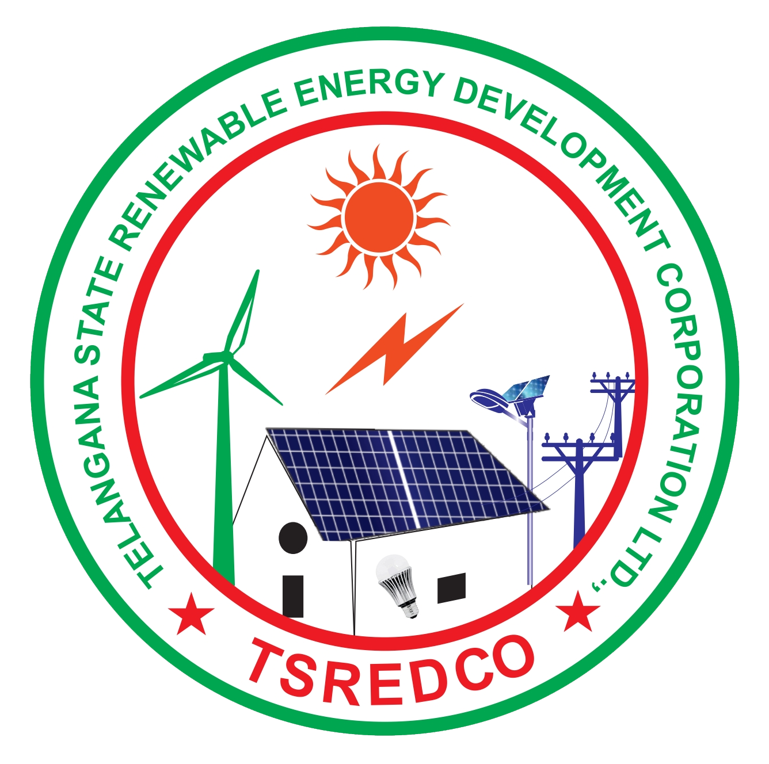
Telangana State Energy Conservation Award for the year 2023

Please fill this pro forma and email to tsecawards@gmail.com along with all the necessary and supportive documents or submit the hard copies at TSREDCO HO as per the time and date mentioned in the guidelines. Use additional sheets, if required

1 | Name of the unit/ Industry
2 | Address
3 | Tel. No. with code |  |  |  |  |  |  |  |  |  |  |  |  | Fax No.
4 | E-mail
5 | Website
6 | Nature of Business
7 | Product / Product mix  (Give product name and specifications)
8 | Name of the CEO/ Director/Owner
8 | Mobile No.
9 | Name of Nodal Person/ point of contact
9 | Mobile No.
10 | Email
11 | Tariff Category/Slab (EHT/HT/LT/ [I, II....])
11 | Contract Maximum Demand in kVA or kW
11 | Average Recorded (2022-23) MD in kVA
11 | Annual Electrical Energy Consumption in  Million kWh (MU) (including self-generation)
12 | Whether applied for any GHG emission reduction program. If yes submit the summary of expected CO₂ reduction per year
13 | Production and Energy Consumption details
 |  |  |  |  |  |  |  |  | UNIT* |  | 2020-21 |  |  | 2021-22 |  |  |  | 2022-23
13.1 | Annual Production |  |  |  |  |  | Product 1 |  | MT
13.1 |  |  |  |  |  |  | Product 2 |  | MT
13.1 |  |  |  |  |  |  | Product 3 |  | MT
13.2 | Total annual Manufacturing Cost |  |  |  |  |  |  |  | Rs. (lakhs)
13.3 | Total annual Energy Cost |  |  |  |  |  |  |  | Rs. Lakhs
13.4 | Energy Cost as % of Production cost |  |  |  |  |  |  |  | %
13.5 | Total Electrical Energy purchased |  |  |  |  |  |  |  | Million kWh
13.6 | Total Electrical Energy Generated |  |  |  |  |  |  |  | Million kWh
13.7 | Fuel used for Power generation (specify type of fuel) |  |  |  |  |  | Calorific Value |  | Ton
13.7 |  |  |  |  |  |  | Calorific Value |  | Ton
13.8 | Total Thermal Energy Consumption  (Except fuel used for power generation) |  |  |  | Furnace Oil |  | Calorific Value |  | Ton
13.8 |  |  |  |  | Coal |  | Calorific Value |  | Ton
13.8 |  |  |  |  | HSD |  | Calorific Value |  | Ton
13.8 |  |  |  |  | Natural Gas |  | Calorific Value |  | Ton
13.8 |  |  |  |  | Others |  | Calorific Value |  | Ton
13.9 | Specific Electrical energy consumption (if possible, normalize to one product) |  |  |  |  |  |  |  | Specify Units
13.10 | Specific Thermal Energy consumption (if possible, normalize to one product) |  |  |  |  |  |  |  | Specify Units
 | *(Specify the unit if the unit is other than given in the table)
14 | Last energy audit conducted on:
14 | Last energy audit conducted by:  (Give name and address of Energy Auditing firm)
14 | Frequency of Energy Audit:  (Please put a √ from the options given) |  |  |  |  |  |  |  | Once in a year
14 |  |  |  |  |  |  |  |  | Once in two years
14 |  |  |  |  |  |  |  |  | Once in three years
14 |  |  |  |  |  |  |  |  | Other, Specify
15 | Energy conservation activities undertaken during the last 3 years
Year |  |  | Project/Program/Activity Title |  |  |  | Category  (Put code no. from below) |  |  | Project cost  (Rs. Lakhs) |  | Annual Savings |  |  |  |  |  | Total
 |  |  |  |  |  |  |  |  |  |  |  | Electricity (kWh) |  |  |  | Fuel (Litres) |  | cost savings  (Rs. Lakhs)
2020-21
2021-22
2022-23
Category |  |  |  | Code no. |  |  |  | Category | Code no. |  |  |  |  |  | Category |  |  |  | Code no.
House keeping |  |  |  | A |  |  |  | Inter fuel substitution | C |  |  |  |  |  | Cogeneration |  |  |  | E
Efficient operation |  |  |  | B |  |  |  | Technology up-gradation | D |  |  |  |  |  | Others |  |  |  | F
16 |  | If you have received any energy conservation awards in last 3 years, mention the year and details.
17 |  | Name of Energy Manager |  |  |  | Name
 |  |  |  |  |  | EM/EA Number
 |  |  |  |  |  | Designation
 |  |  |  |  |  | e-mail
 |  |  |  |  |  | Telephone
18 |  | Furnish the details of Energy Policy and Energy Conservation Committee/Cell/Circles functioning in your organization. (use additional sheets if required)
19 |  | Details on training programs/ webinars/campaigns in energy Conservation organized/conducted in 2022-23. |  |  |  |  |  |  |  | 1  2  3  4
20 |  | Details of innovative technologies implemented in energy efficiency and conservation: |  |  |  |  |  |  |  | 1  2  3  4
21 |  | Details of renewable energy projects: |  |  |  |  |  |  |  | 1  2  3  4
Details to be attached as follows (use separate sheets)
- Unit Profile (100 words)
- Energy Management Policy, if any
- Specification of Captive power plants (Rating in kVA and specification of DG set/ TG set)
- If Cogeneration, specification of Cogeneration plant (with schematic diagram)
- Graphical Representation of Specific Energy Consumption
- Energy conservation cell structure, if any
- Major Energy Conservation Projects Implemented during the Year 2022-23 (brief description with photo)
- Other Energy projects implemented during 2022-23.
- Future Energy Conservation Plans and Targets
- Details regarding Environment and Safety.
- Annual Report. (Optional).
- Supporting documents related to statutory requirements such as PCB clearance etc.

It is to certify that the enterprise/organization is presently following all the statutory requirements pertaining to the safety and pollution control and the facts stated above are true and correct to the best of my knowledge and belief.

Date
Place
Signature of CEO/ Unit Head

Name & Designation:

(Office Seal)

