
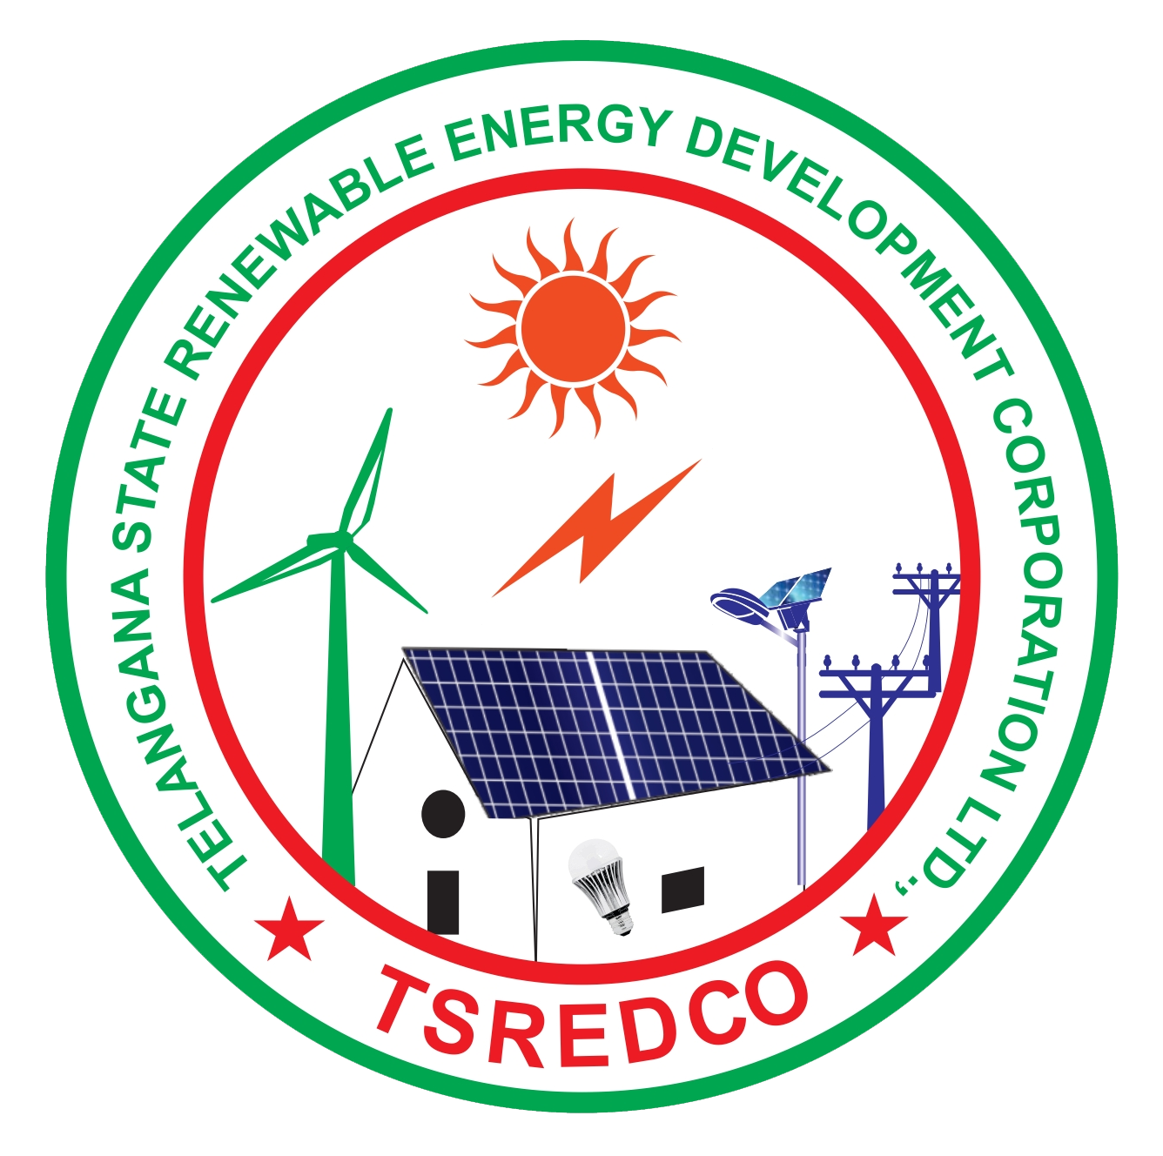
Telangana State Energy Conservation Award for the year 2023

Please fill this pro forma and email to tsecawards@gmail.com along with all the necessary and supportive documents or submit the hard copies at TSREDCO HO as per the time and date mentioned in the guidelines. Use additional sheets, if required

1 | Name
2 | Address
3 | Tel. No. with code |  |  |  |  | Fax no. |  |  |  |  | Fax No.
4 | Website
5 | Name of the Owner/CEO/Director
5 | Mobile No.
5 | E-mail
6 | Name of the Nodal Person/ Point of Contact
6 | Mobile No.
6 | E-mail
7 | Type of Building/Activity  (E.g.: Office, Hotel, Hospital etc.)
8 | Total Plot/ Land Area (m²)
9 | No of Blocks/ No. of floors |  |  |  |  | 1. Block ___/ ____ Floors  2.  3.  4.
10 | Type of Ownership/ Occupancy type  (whether Government/ private/ Local Self Government, whether occupied by the owner/ applicant or rented etc) |  |  |  |  | Eg.: Government/occupied by owner
11 | Electricity Tariff Category/ Slab (EHT/HT/LT/[I,II....])
11 | Contract Maximum Demand (kVA) or Connected Load (kW)
11 | Average Recorded (2022-23) MD in kVA or kW
12 | Mention whether Certified Green Building or BEE star rated or ECBC complied (attach proof)
13 | Whether applied for any GHG emission reduction program. If yes submit the summary of expected CO₂ reduction per year along with supporting document
14 | Building Area and Connected Load |  |  |  |  | 2020-21 |  |  |  |  |  | 2021-22 |  |  |  | 2022-23
14.1 | Total Built up Area (in m²)
14.2 | Air-conditioned area (in m²)
14.3 | Non-Air-conditioned area (in m²)
14.4 | Occupancy rate (Unit in % or Numbers)
14.5 | Total Connected Load (in kW)
14.6 | Building operating hours
15 | Energy Consumption
 | Energy used (Annual) |  |  |  | Units |  |  | 2020-21 |  |  |  |  | 2021-22 |  |  | 2022-23
(15 a) | Electricity Purchased |  |  |  | kWh
(15 b) | Self-generated |  |  |  | kWh
(15 c) | Total Electricity Consumption  (15 a+ 15 b) |  |  |  | kWh
(15 d) | If Self-generated is not totally consumed then Energy exported |  |  |  | kWh
(15 e) | Specific Energy Consumption w.r.t total built up area,  Total Electricity consumption/ Total built-up area  {(kWh/m²) = (15 c) / (14.1)} as given against above row) |  |  |  | kWh/m²/ annum
(15 f) | Type of Energy used other than electricity (select an option) |  |  |  | Yes / No
(15 f) | If Yes, Type of fuel |  |  |  | 1.  2.
(15 f) | Fuel wise Consumption (mention the units) |  | 1 |  | Units
(15 f) |  |  | 2 |  | Units
(15 g) | Source for self-generation (solar/ other fuels) |  | 1  2
(15 h) | Fuel Consumption for Self Generation other than solar/ wind (mention the units) |  | 1 |  | Units
(15 h) |  |  | 2 |  | Units
16 | Last energy audit conducted on:
16 | Last energy audit conducted by:  (Give name and address of Energy Auditing firm)
16 | Frequency of Energy Audit:  (Please put a ✔ from the  options given) |  |  |  | Once in year
16 |  |  |  |  | Once in two years
16 |  |  |  |  | Once in three years
16 |  |  |  |  | Other, Specify
17 | Details of Energy Manager (If BEE Certified give Certification Number) |  |  | Name
17 |  |  |  | EA/EM No.
17 |  |  |  | Designation
17 |  |  |  | e-mail
17 |  |  |  | Telephone
18 | Energy conservation activities undertaken during the last 3 years
 |  |  |  |  | Investment |  |  |  |  | Annual Savings |  |  |  |  |  | Total
Year | Project/Program/Activity Title |  |  |  | (Rs. lakhs) |  |  |  |  | Electricity (kWh) |  |  |  | Fuel  (Litres) |  | cost savings  (Rs.lakhs)
2020-21 | 1
2020-21 | 2
2020-21 | 3
2021-22 | 1
2021-22 | 2
2021-22 | 3
2022-23 | 1
2022-23 | 2
2022-23 | 3
19 | Have you received any energy conservation awards in last 3 years? If yes, mention the year and details
20 | Details of training programs/campaigns in energy Conservation organized/conducted in 2022-23 (mention the title here and attach the relevant document) |  |  |  |  |  |  |  | 1  2  3
21 | Details of innovative technologies implemented for energy conservation including utilization of renewable energy projects.  (Mentioned the title here and attached the relevant document) |  |  |  |  |  |  |  | 1  2  3
Applicant has to attach the following details (use additional sheets for below details)
- Unit Profile (100 words)
- Energy Management Policy, if any
- Energy conservation cell / department /section structure
- Graphical Representation of Specific Energy Consumption
- Major Energy Conservation Projects Implemented during the Year 2022-23 (brief description with photo)
- Other energy related projects implemented during 2022-23
- Energy Conservation future Plans and Targets
- Details regarding Environment and Safety – any certifications received please attach the copies of the same
- Attach the copies of energy consumption details as proof for section 15 (Electricity bills, fuel bills etc.)
- Attach the copies of all the details mentioned in the application as proof

It is to certify that the enterprise/organization is presently following all the statutory requirements pertaining to the safety and pollution control and the facts stated above are true and correct to the best of my knowledge and belief.

Date
Place

Signature of CEO/Head/Incharge

Name & Designation:

(Office Seal)

