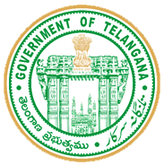
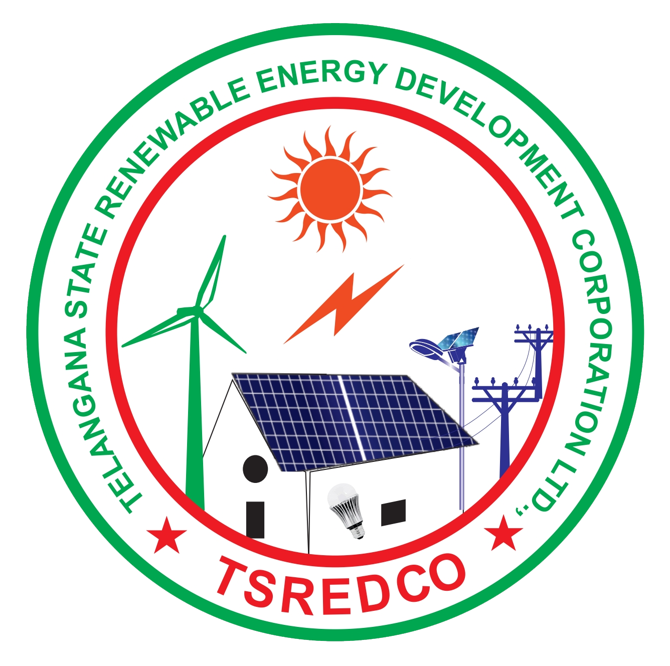
Telangana State Energy Conservation Award for the year 2022
Pro forma to substantiate the achievements in energy conservation
Urban Local Bodies
Please fill this pro forma and email to tsredco.awards@gmail.com along with all the necessary and supportive documents or submit the hard copies at TSREDCO HO as per the time and date mentioned in the guidelines. Use additional sheets, if required
S.No | General Description
1 | Name of the ULB
2 | Year of Formation
3 | Complete address of ULB  (including Chief Executive’s name & designation) with telephone, fax nos., E-Mail and Mobile nos. (All details to be submitted)
4 | Name, designation, address, telephone, mobile, fax nos. & E-Mail of responsible person who could be contacted in connection with the application for Award  (All details to be submitted)
5 | Description of the ULB and Connected Load (kW)
6 | Name of the Commissioner/ CEO/ MD/ Competent Authority
7 | Email
8 | Mobile No.
9 | Name of the technical officer/ engineer looking after energy related activities
10 | Email
11 | Mobile No.
12 | General Description |  |  |  | Units |  | 2019-20 |  | 2020-21 |  | 2021-22
(i) | Total Area of Coverage |  |  |  | Sq. kms
(ii) | Population |  |  |  | Lakhs
(iii) | Number of Street lights installed |  |  |  | No.s
(iv) | Total Area Covered for Streetlights |  |  |  | Sq. kms
(v) | Quantity of drinking water pumped |  |  |  | Million m³ /year
(vi) | Total Area Covered for Water pumping |  |  |  | Sq. kms
(vii) | Quantity of Sewage Pumped |  |  |  | Million m³ /year
(viii) | Total Area Covered for Sewage pumping |  |  |  | Sq. kms
(ix) | ECBC complied buildings under ULB |  |  |  | Numbers
(x) | ECBC complied built-up area (attach the copies of ECBC TPA certificates uploaded by the building applicants through DPMS) |  |  |  | Sq. m
13 | Electricity Energy Consumption in the ULB
 | Particulars |  |  |  | Units |  | 2019-20 |  | 2020-21 |  | 2021-22
(a) | Electricity consumption for street lighting |  |  |  | Million kWh
(b) | Electricity consumption for drinking water pumping |  |  |  | Million kWh
(c) | Electricity consumption for sewage pumping |  |  |  | Million kWh
(d) | Electricity Consumption (purchased from DISCOM only for services) (d = a+b+c) |  |  |  | Million kWh
(e) | Self-generated |  |  |  | Million kWh
(f) | Total Electricity Consumption (f=d+e) |  |  |  | Million kWh
(g) | Specific Electrical Energy Consumption in Street lightening/ total area covered  [13 (a) / 12 (iv)] |  |  |  | Million kWh/km²
(h) | Specific Electrical Energy Consumption in drinking water pumping / Quantity of water supplied / area of coverage  [{13 (b) /12 (v)} / 12 (vi)] |  |  |  | kWh / m³/area covered in m²
(i) | Specific Electrical Energy Consumption in Sewerage pumping / Quantity of sewerage pumped / area of coverage  [{13 (c) / 12 (vii)} / 12 (viii)] |  |  |  | kWh / m³/area covered in m²
Specific Energy Consumption (SEC) Reduction during the period 2019 - 2022
(j) | % Reduction over preceding year in street lighting |  |  |  | %
(k) | % Reduction over preceding year in Water Pumping |  |  |  | %
(l) | % Reduction over preceding year in Sewerage Pumping |  |  |  | %
14 | Achievement of energy savings from implementation of new Energy Efficiency Projects during the year 2019 -22 (The energy savings achieved shall only the projects which have been implemented during 2019-22) –Attach
 | Year | Annual Electricity Savings (Million kWh) |  |  |  |  | Any Other
 | 2019-20
 | 2020-21
 | 2021-22
15 | Absolute Savings
 | Elect. Saving  (Million kWh) in  2020-21 |  | Elect. Consumption (Million kWh) in  2019-20 | % Elect. Saving (savings achieved/ electricity consumption of proceeding year) |  | Elect. Saving  (Million kWh) in  2021-22 |  | Elect. Consumption (Million kWh)  In 2020-21 |  | % Elect. Saving (savings achieved/ electricity consumption of  proceeding year)
 | (i) |  | (ii) | ((i)/(ii))x100 |  | (iii) |  | (iv) |  | ((iii)/(iv)) x 100
16. Other Information
16.1 | Have you received any energy conservation awards in last 3 years? If yes, mention the year and details |  |  | 1.  2.
16.2 | Details of training programs/campaigns in energy Conservation organized/conducted in 2021-22 (mentioned the title here and attached the relevant document) |  |  | 1  2  3
16.3 | Details of Energy Conservation Studies conducted in 2021-22 (attached the relevant document)
16.4 | Attach the copy of electricity bills or abstract certified by competent authority of ULB as proof from 2019-20 to 2021-22

It is to certify that the above stated information is true and correct to the best of my knowledge and belief.

Date
Place
Authorized Signature

Name & Designation:

(Office Seal)

