
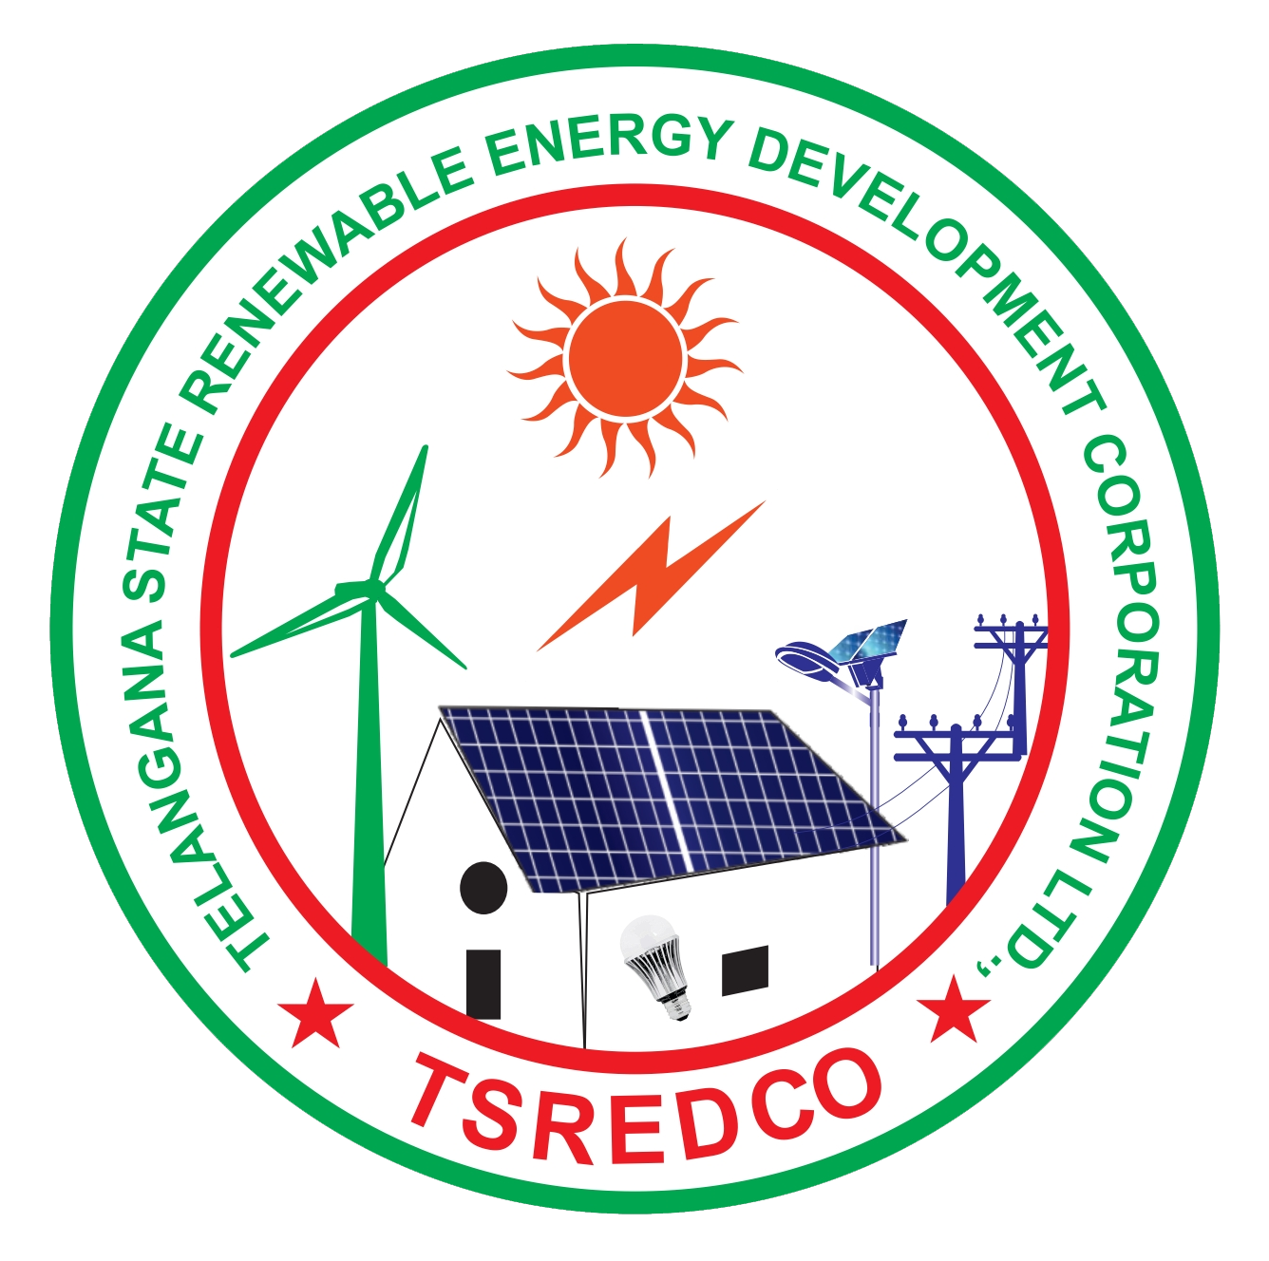
Telangana State Energy Conservation Award for the year 2020
Pro forma to substantiate the achievements in energy conservation
Urban Local Bodies
Please fill this pro forma and email to tsredco.awards@gmail.com. Use additional sheets, if required

S.No | General Description
1 | Name of the ULB
2 | Year of Formation
3 | Complete address of ULB (including Chief Executive’s name & designation) with telephone, fax nos., E-Mail and Mobile nos. (All details to be submitted)
4 | Name, designation, address, telephone, mobile, fax nos. & E-Mail of responsible person who could be contacted in connection with the application for Award (All details to be submitted)
5 | Description of the ULB and Connected Load (kW)
6 | Name of the Commissioner/ CEO/ Director/ Competent Authority
7 | Email
8 | Mobile No.
9 | Name of the technical officer/ engineer looking after energy related activities
10 | Email
11 | Mobile No.
12 | General Description |  |  |  | Units |  | 2017-18 |  | 2018-19 |  | 2019-20
(i) | Total Area of Coverage |  |  |  | Sq. kms
(ii) | Population |  |  |  | Lakhs
(iii) | Number of Street lights installed |  |  |  | No.s
(iv) | Total Area Covered for Streetlights |  |  |  | Sq. kms
(v) | Quantity of drinking water pumped |  |  |  | Million m³ /year
(vi) | Total Area Covered for Water pumping |  |  |  | Sq. kms
(vii) | Quantity of Sewage Pumped |  |  |  | Million m³ /year
(viii) | Total Area Covered for Sewage pumping |  |  |  | Sq. kms
(ix) | ECBC complied buildings under ULB |  |  |  | Numbers
(x) | ECBC complied built-up area (attach the copies of ECBC TPA certificates uploaded by the building applicants through DPMS) |  |  |  | Sq. m
13 | Electricity Energy Consumption in the ULB
 | Particulars |  |  |  | Units |  | 2017-18 |  | 2018-19 |  | 2019-20
(a) | Electricity consumption for street lighting |  |  |  | Million kWh
(b) | Electricity consumption for drinking water pumping |  |  |  | Million kWh
(c) | Electricity consumption for sewage pumping |  |  |  | Million kWh
(d) | Electricity Consumption (purchased from DISCOM only for services) (d = a+b+c) |  |  |  | Million kWh
(e) | Self-generated |  |  |  | Million kWh
(f) | Total Electricity Consumption (f=d+e) |  |  |  | Million kWh
(g) | Electrical Energy Consumption in Street lightening/ total area covered  [13 (a) / 12 (iv)] |  |  |  | Million kWh/km²
(h) | Electrical Energy Consumption in drinking water pumping / Quantity of water supplied / area of coverage  [{13 (b) /12 (v)} / 12 (vi)] |  |  |  | kWh / m³/area covered in m²
(i) | Electrical Energy Consumption in Sewerage pumping / Quantity of sewerage pumped / area of coverage  [{13 (c) / 12 (vii) } / 12 (viii)] |  |  |  | kWh / m³/area covered in m²
Specific Energy Consumption (SEC) Reduction during the period 2017 - 2020
(j) | % Reduction over preceding year in street lighting |  |  |  | %
(k) | % Reduction over preceding year in Water Pumping |  |  |  | %
(l) | % Reduction over preceding year in Sewerage Pumping |  |  |  | %
14 | Achievement of energy savings from implementation of new Energy Efficiency Projects during the year 2017 -20 (The energy savings achieved shall only the projects which have been implemented during 2017-20) –Attach
 | Year | Annual Electricity Savings (Million kWh) |  |  |  |  | Any Other
 | 2017-18
 | 2018-19
 | 2019-20
15 | Absolute Savings
 | Elect. Saving  (Million kWh) in  2018-19 |  | Elect. Consumption (Million kWh) in  2017-18 | % Elect. Saving (savings achieved/ electricity consumption of proceeding year) |  | Elect. Saving  (Million kWh) in  2019-20 |  | Elect. Consumption (Million kWh)  In 2018-19 |  | % Elect. Saving (savings achieved/ electricity consumption of  proceeding year)
 | (i) |  | (ii) | ((i)/(ii))x100 |  | (iii) |  | (iv) |  | ((iii)/(iv)) x 100
16. Other Information
16.1 | Have you received any energy conservation awards in last 3 years? If yes, mention the year and details |  |  | 1.  2.
16.2 | Details of training programs/campaigns in energy Conservation organized/conducted in 2019-20 (mentioned the title here and attached the relevant document) |  |  | 1  2  3
16.3 | Details of Energy Conservation Studies conducted in 2019-20 (attached the relevant document)
16.4 | Attach the copy of electricity bills or abstract certified by competent authority of ULB as proof from 2017-18 to 2019-20

It is to certify that the above stated information is true and correct to the best of my knowledge and belief.

Date
Place
Signature of CEO/ Unit Head

Name & Designation:

(Office Seal)

